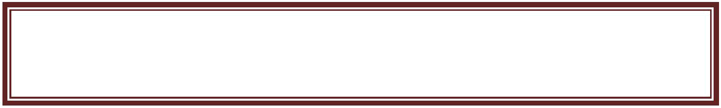
The Lightship
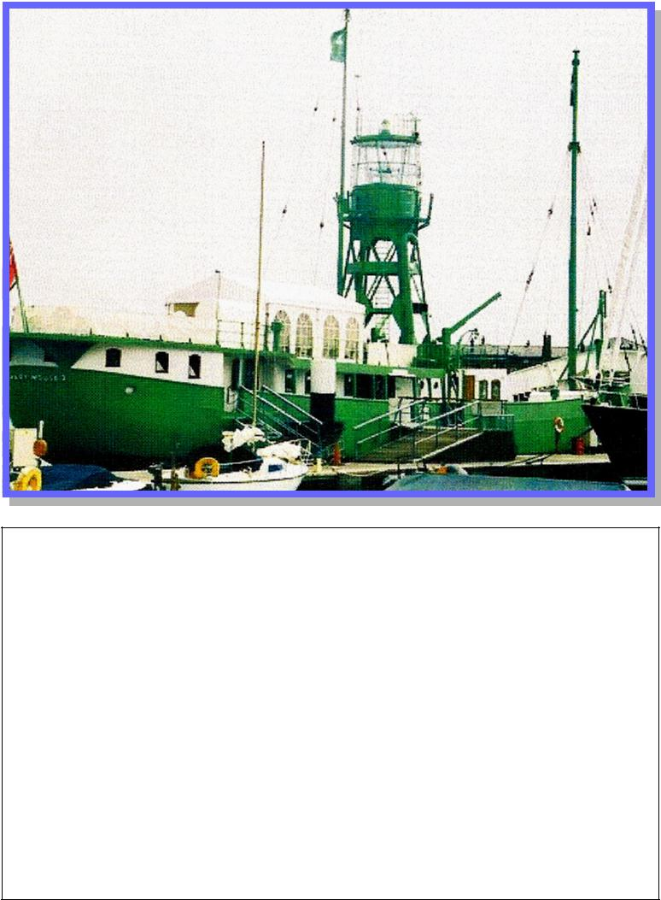

Size of ship: Overall length 13725 feet 26 feet beam

Displacement 450 t Built in 1947 - £50,392

Brought for £25,000 in 1992 to be used as a wave break at Haslar Marina.

History of the Corporation of Trinity House

The safety of shipping, and the welfare of sea-farers is their prime concern since Trinity House was granted a Royal Charter by Henry VIII in 1514.

The first Master of Trinity House was a Thomas Spert who was also captain of Henry VIII flag-ship Mary Rose.

1514 Charter is granted

1609 First Lighthouse at Lowestoft

1698 Eddystowe becomes first rook lightship in Europe

1732 Worlds first Light vessel is moved to Nore Sands in Thames Estuary by it inventor Robert Hamblin.

1867 Electricity introduced to first light house

1969 First relief of lighthouses by helicopter.
Mary Mouse Lightship History 04.1945 Ordered by Trinity House, London

04.10.1946 Handed over 11/1946-12/1948 Royal Sovereign station 02/1949-05/1956 Tongue station 08/1956-06/1959 Outer Gabbard station 10/1959-01/1963 Tongue station 06/1963-06/1966 Smith´s Knoll station 09/1966-04/1967 Shambles station 08/1967-12/1967 Seven Stones station 03/1968-07/1968 Smith´s Knoll station 11/1968-03/1969 Shipwash station 05/1969-08/1969 Humber station 06/1970-10/1970 Royal Sovereign station 10/1970-03/1971 Galloper station 03/1971-08/1971 Owers station 11/1971-03/1972 Varne station 08/1972-11/1972 Shipwash station 05/1974-09/1974 Cross Sand station 09/1974-01/1975 Dudgeon station 02/1975-06/1975 Humber station 06/1975-11/1975 Outer Gabbard station 11/1975-03/1976 Tongue station 06/1976-04/1983 East Goodwin station 04/1985-04/1988 Tongue station 06/1989-10/1991 Dowsing station

1993 Decommissioned

10/1993 sold to Dean & Reddyhoff Ltd., Southampton, for use as marina club house at Gosport, Hampshire.
What is a Lightship?

A Lightvessel or Lightship is a ship which acts as a lighthouse. They are used in waters that are too deep or otherwise un-suitable for lighthouse construction.

The now named Mary Mouse II Lightship was built in 1947 by Philips and Son in Dartmouth. Philip and Son Ltd built 35 light vessels, including 29 for Trinity House, five for the Commissioners of Irish Lights and one for the Mersey Docks and Harbour Board.

This Lightship was taken out of commis-sion in 1993 and sold to Dean and Reddy-hoff Ltd for their Haslar Marina Project. It was painted green and renamed Mary Mouse II after the director’s wives Mary Reddyhoff and Joanna (Mouse) Dean.
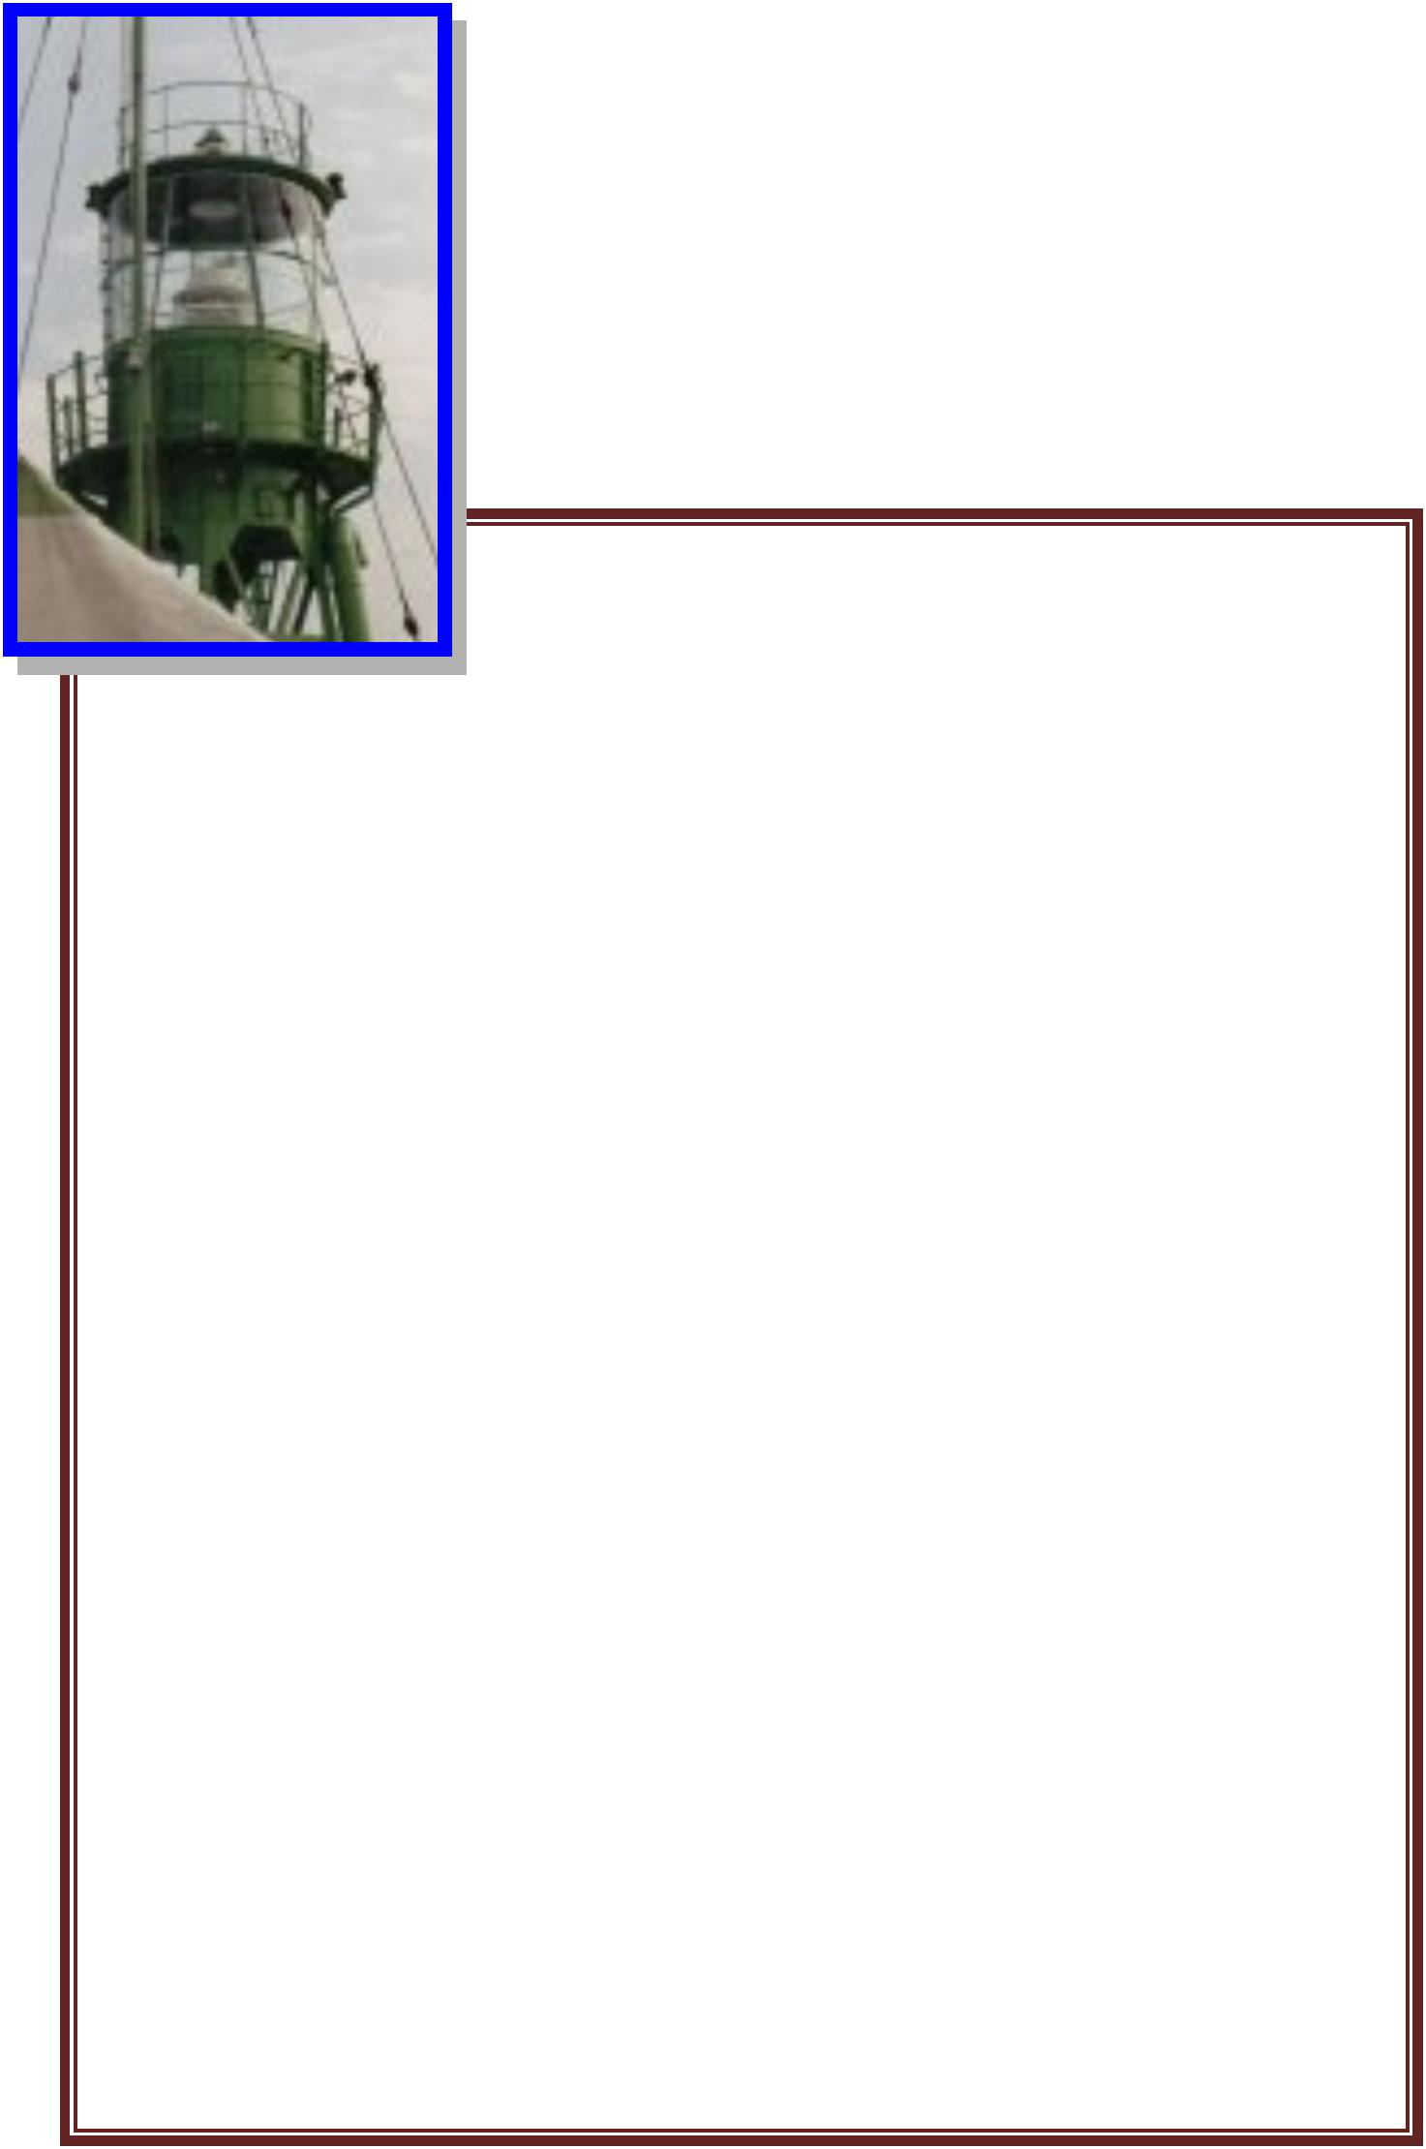

The Light vessels used to be fully manned by a crew of 6-8 people keeping watch 24

hours a day. Their prime function was to maintain operation of the ves-sel and the lantern, but they would also send in regular weather reports to the Meteorological Office. Initially crews would have been relieved by boat but a helicopter deck was added later to ease this process. Later the crews became redundant and all ac-commodation was stripped out leav-ing a sealed empty hull with two gen-erators and a light.
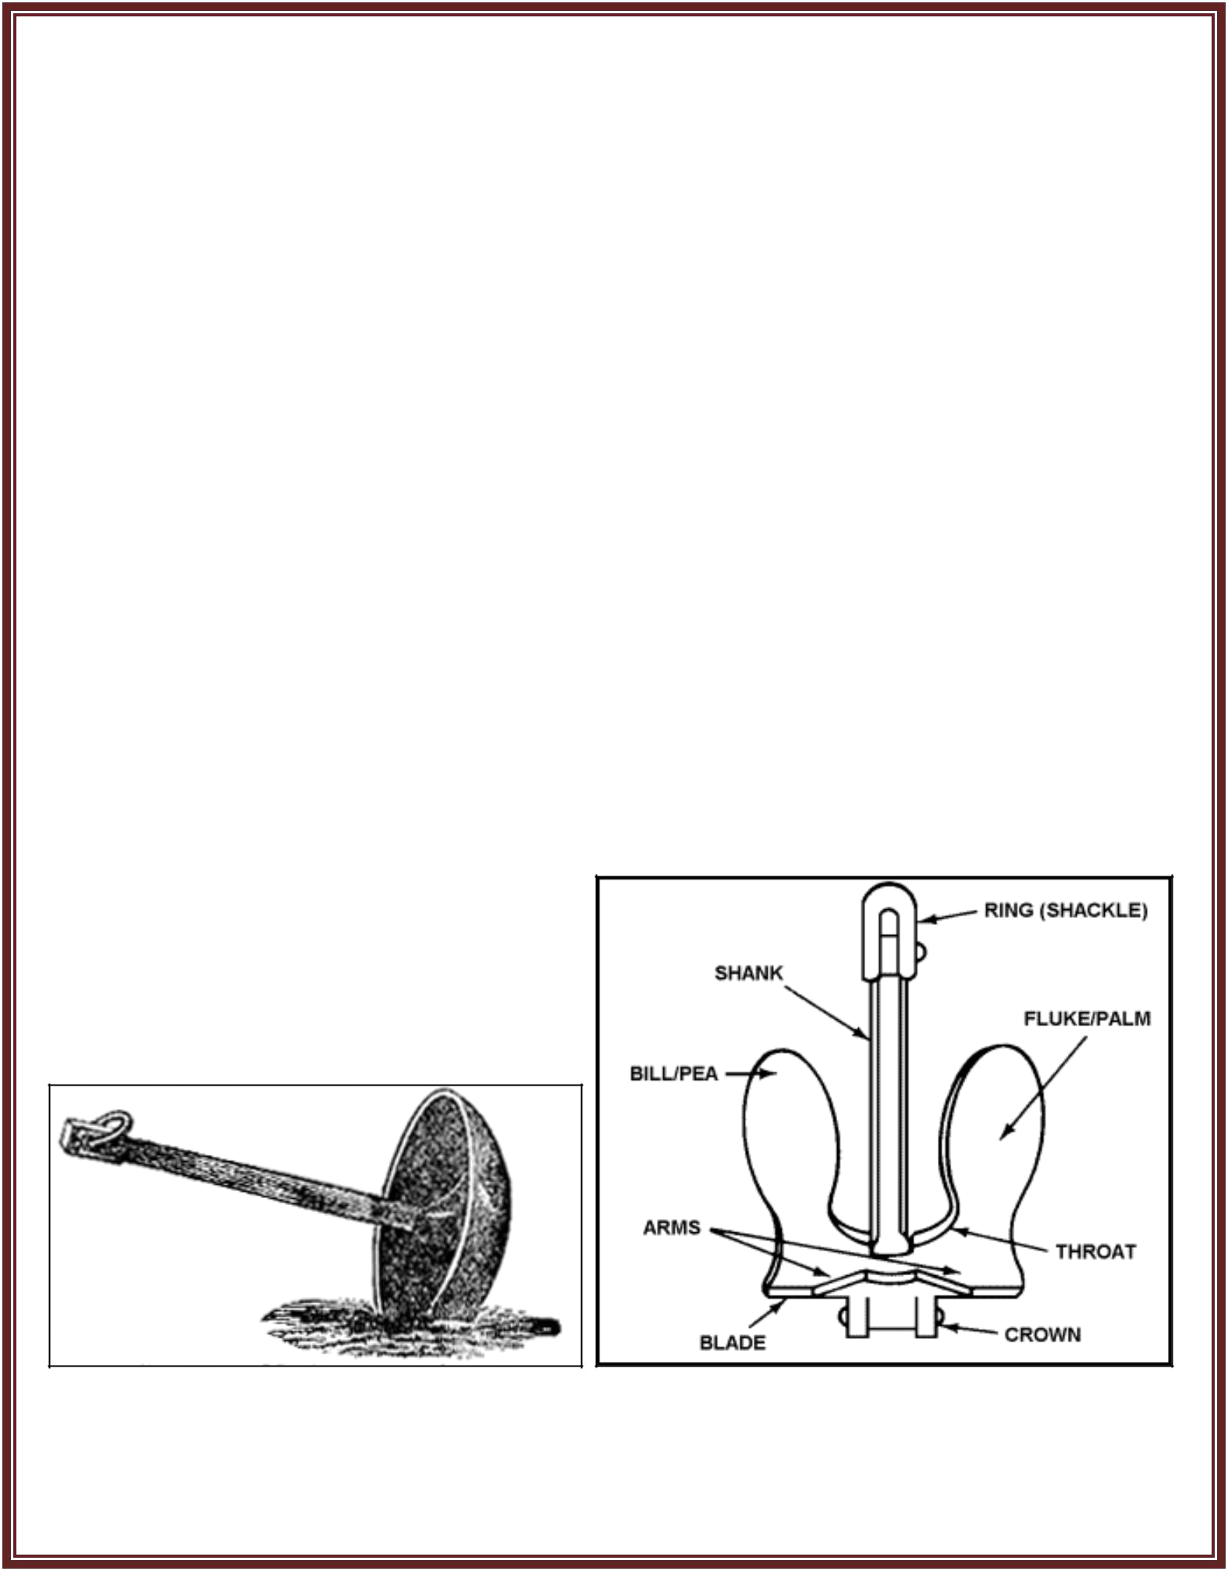
Mooring

Holding the vessel in position was an im-portant part of the lightship engineering – early vessels used fluke anchors, which are still used on some contemporary vessels. However, these anchors are prone to dragging, so since the early 19th century lightships have used mushroom anchors weighing 3-4 tons.

MUSHROOM ANCHOR FLUKE ANCHOR


Paul Jones and Clare Jefferson-Jones of Splodge Designs would like to say thank you to all the people who have made the development and crea-tion of this project possible.

Including: Creative Landscapes with Liz Porter, Esther Gill and Cynara Da-vies, Terry Rhodes, all involved in HOD Inclusion Group, David Taylor, Tony Elbourn and his group, Richard Sturgess, Mycroft Tierney.

